MinnKota Club of the Year Nomination

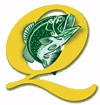
Quality Bass Club
San Antonio, TX
South Texas Region

Quality Bass Club, based in San Antonio, TX, represents a tightly-knit group of 14 permanent members. Along with their thrill of bass fishing, Quality Bass Club has emphasized its service to community, protection of the environment, continuation of B.A.S.S. concepts, and, most importantly, promotion of the great outdoors to our youth. And although membership is small, the members have made a phenomenal impact in all these areas during 2003.
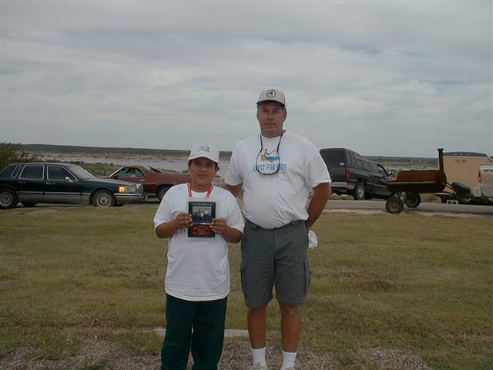 | 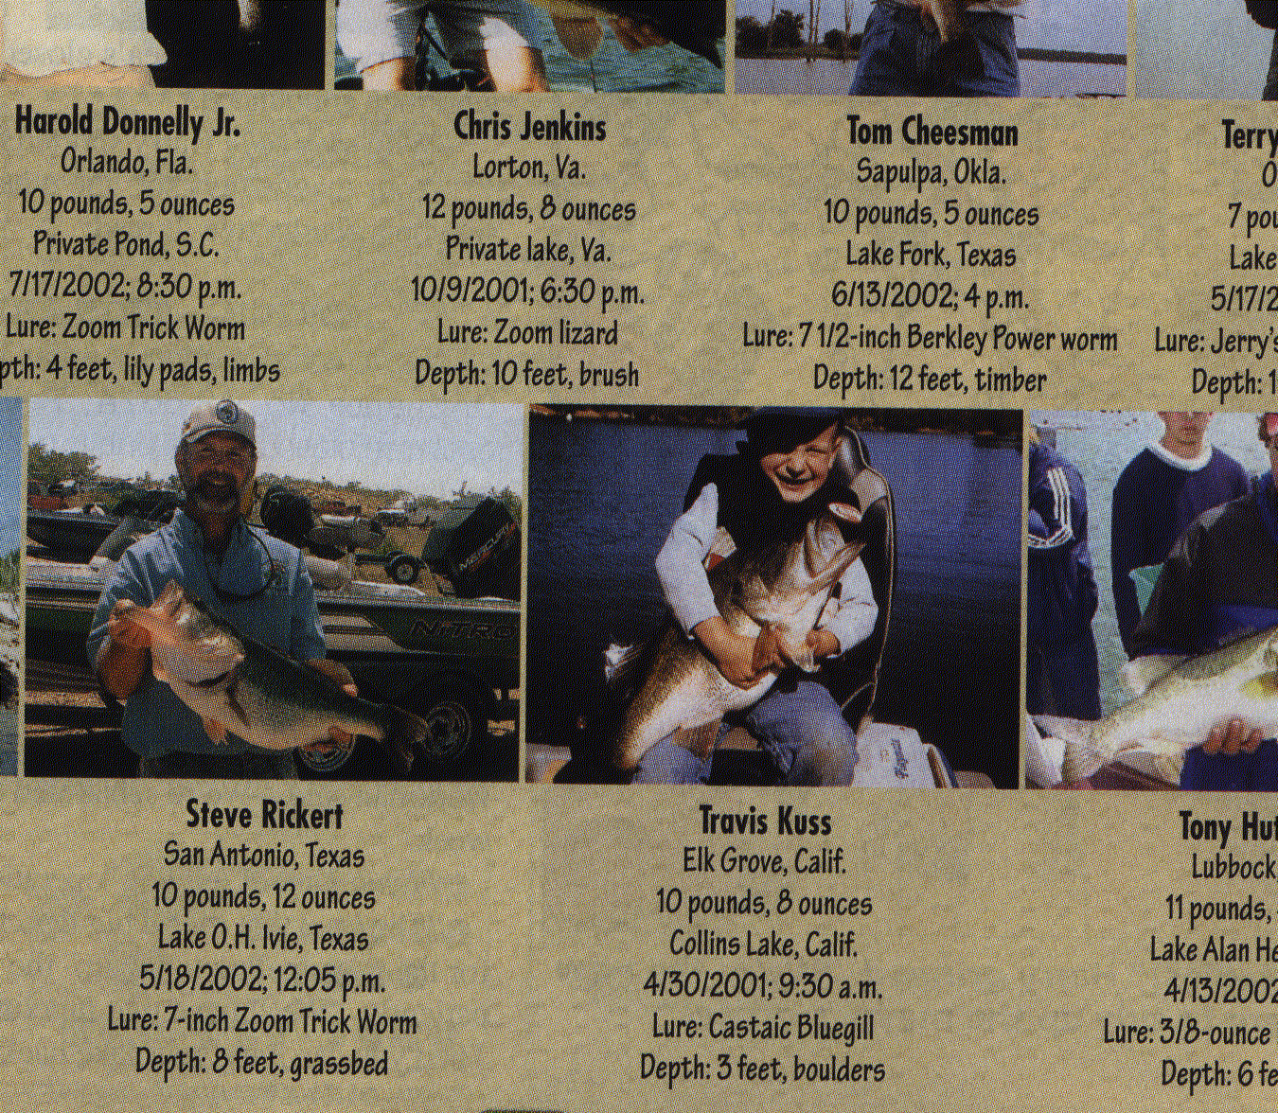 | 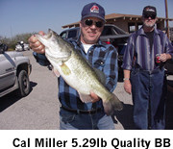 | 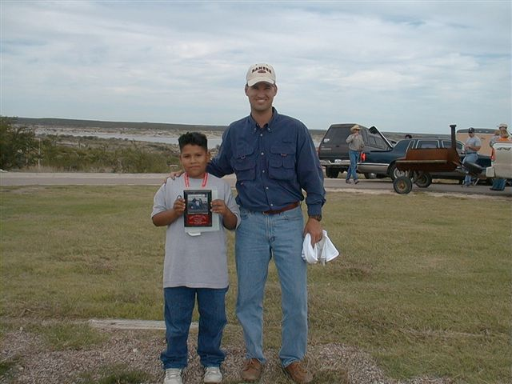
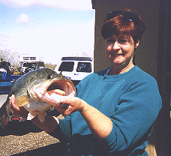 |  |  | 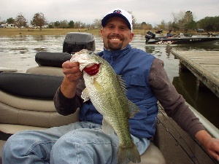
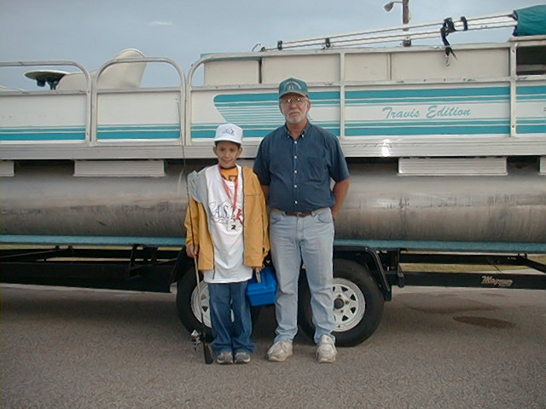 |  | 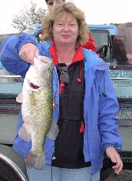 | 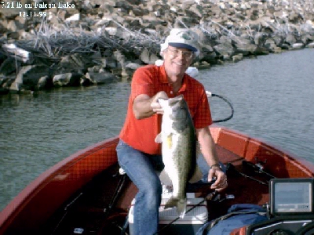

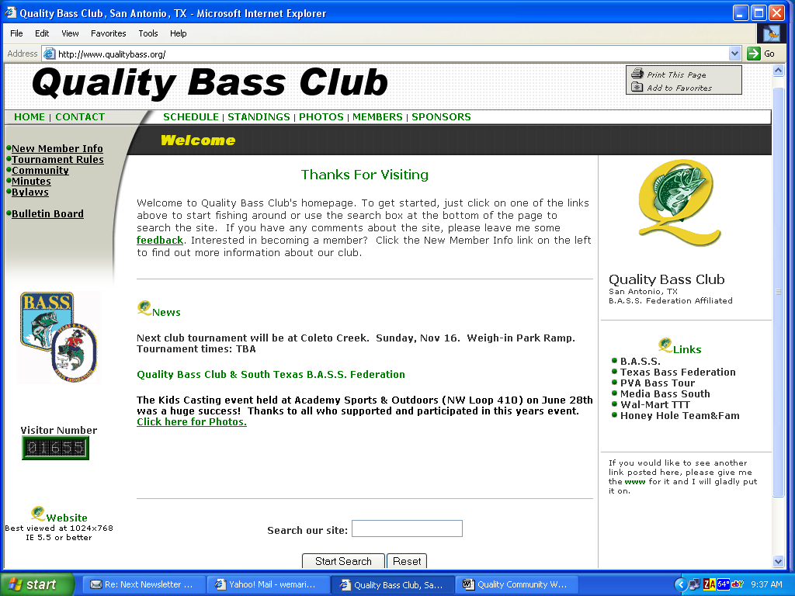
One of the first orders of business in 2003 was to continue to improve and revamp the club’s website. Not only is a “fresh look” important to keeping the information updated, but it’s also critical in keeping and finding outside interest in our club, B.A.S.S. and the Federation. Clint Baker, the club’s Internet Coordinator and proud Paralyzed Veterans of America (PVA) fisherman, does a fabulous job keeping up with the dissemination of information throughout the club on tournament times, minutes, standings, by-laws, etc. This year the website received over 1,600 visits and over 3,500 page views. The club also ended the year as the sole remaining South Texas Region site on the web. In fact, the web site was the primary source for several new memberships again in 2003. And finally, the web site was our little way of sending a big thanks to all of our sponsors. Without them, our ability to support the Federation and local charities would be critically hampered.

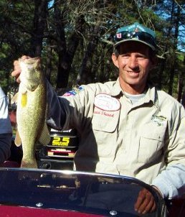
The club had another special year with its PVA members. In the early part of the year, the club, region, and state sponsored our national qualifier, Dave Stewart to compete at the National PVA tournament at Lake Havasu from February 21st-23rd. Dave did quite well in finishing just out of the qualifiers for the last day and finished in 9th place overall. This year, both Dave Stewart and Clint Baker have qualified for this prestigious event… a phenomenal point given that only 25 in the nation qualify. Both started with the club in 2002 as the clubs’ first disabled fishermen and both have made tremendous impacts.
The next order of business was the support of the 13th Annual San Antonio Pest Control Association (SAPCA) Open Team Bass Tournament in May 2003 at Choke Canyon. And this again was no ordinary tournament. The main purpose was to support the Autistic Center of San Antonio. As it has for the last few years, Dan Leach, Quality Bass President, and the club moved quickly to ensure it assisted the SAPCA. Not only did all the club members participate, the club also kept its multi-year sponsorship streak alive with another gold monetary donation to the charity. Then, one club member, Ms Cathy Teague-Leach, took it a step further by purchasing high-demand items with this money so that they could be auctioned. This resulted in almost a two-fold payback for the charity—the Autistic Children's Center of Texas.

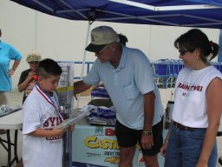
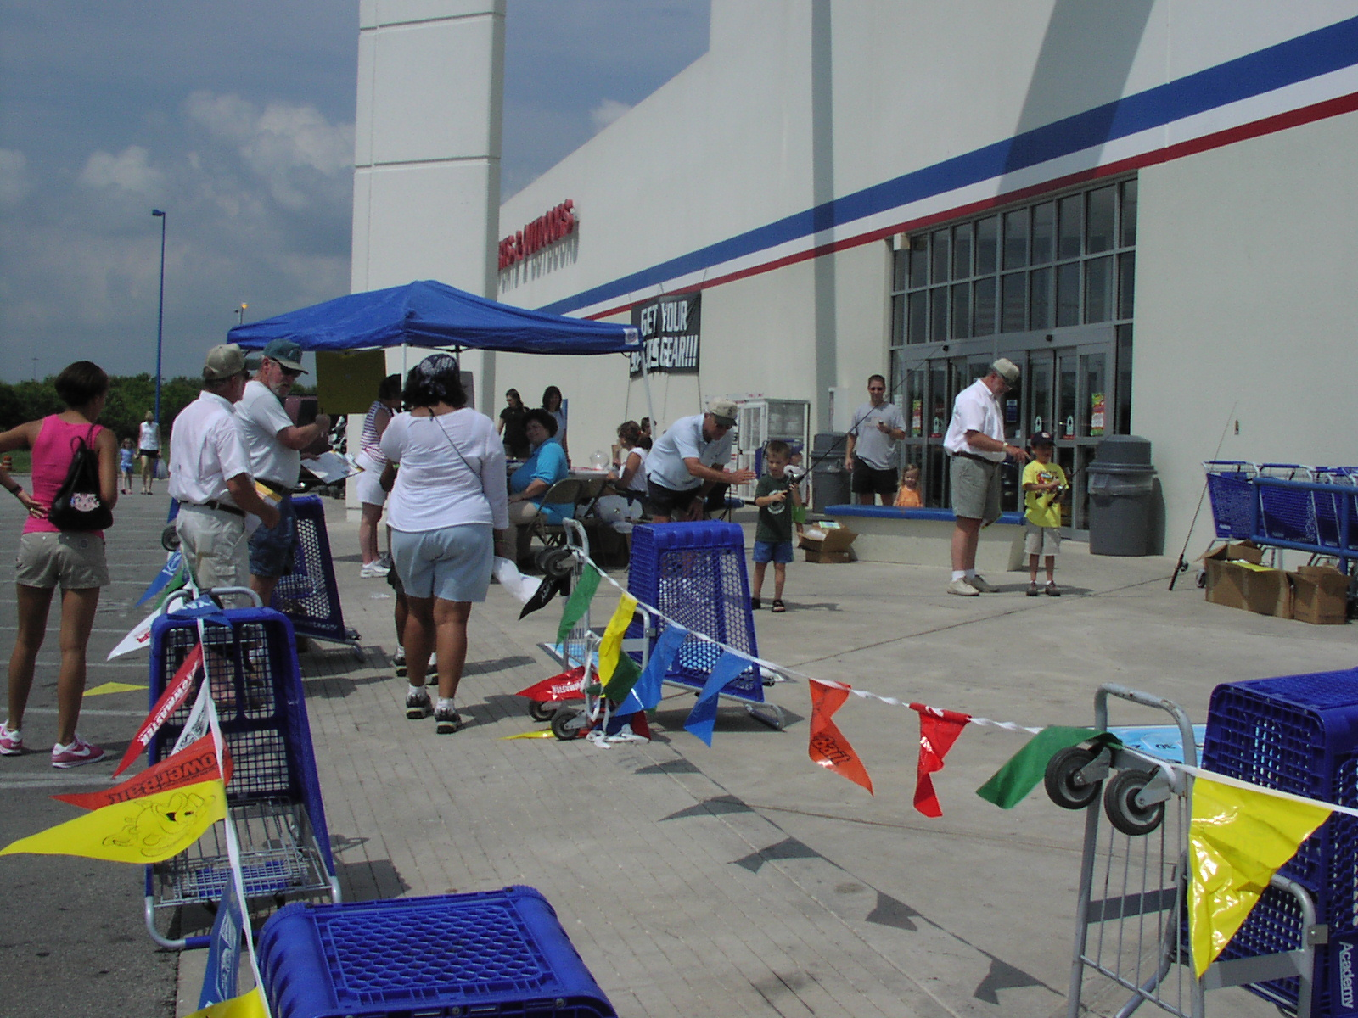

Next, on June 28, from 11 am to 2 pm, the club teamed up again with one of its core sponsors, Academy Sports and Outdoors, and held a Casting Kids event on NW Loop 410. This marked the 4th year in a row for the club to host an event, an unmatched record in the entire South Texas region. In the end, we had an incredible 50+ kids “officially” participate and 20+ more (who were either over or under the eligible age) who participated just for fun. Quality Bass Club also chipped in an gathered a ton of fishing lures, worms, Academy sunglasses, and hooks to create some awesome tackle packs for give-aways. The kids loved their slimy lures and shiny hooks and every kid went away with a smile on their face and as a winner. We knew the kids really enjoyed themselves when many of them wouldn’t leave their practice stations of pitchin', castin', and flippin' and many had to be dragged away by their parents because they wanted to “fish” more. The smiles were too many to count…
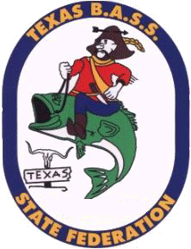
In August, Quality Bass Club assisted the local regional Federation championship tournament at Amistad by hosting their weigh-in. When South Region Director, Ron Castle needed help with the championship, Quality Bass was more than happy to jump in. They performed everything from check-in, weigh-in, and calculation of the prize catches, so that Ron could focus on fishing the championship. The project was a successful venture for the club and a big help to running a Federation championship. It also served as a “test run” for Bill Marion who was later that year elected into the South Texas Regional Director position for 2004-2005.
Next, was Quality's mainstay event—the annual fish fry, raffle, and auction in August. Besides a great gathering of locals enjoying the camaraderie and great fried fish and hushpuppies, the event's raffle and auction raised necessary funds for the anglers in the next year’s Top 6 tournament and most importantly, our club charity events. This year’s event resulted in over 150 plates being sold! In 2003 the club raised over $500 for local charities for 2004.


We do this by developing great relationships with many local and national sponsors as:



They provided essential support for our community with their donations for our auctions and fund raisers. To top it all off with a bit of fun, the event always ends with the infamous $100+ pie-in-the-face contest—always a sight to see! The picture below is our humble Sergeant at Arms and gentle giant, George Barnes, getting prepared for the cold-n-creamy pie that sold for over one hundred dollars. What a worthy sacrifice to raise money for our youth and local charities!

In September, a call came out from Jim Murray, a South Texas custom leather maker and Falcon Lake local guide requesting support for Falcon. As many in Texas know, Falcon Reservoir has experienced drought conditions, illegal netting, poor launch conditions, and over-drawing from this impound for almost 10 years. Jim stepped up to form the Save Falcon Lake Association and Quality Bass Club was close behind with their support. Many in the club moved quickly to support the letters to the State and National legislators and also sign the petition that Jim had started. Additionally, many are planning to support the “boat ride through Austin” campaign that is being planned for 2004 to spark interest and hopefully state and national agreement and action for the Falcon lake situation. SFLA will be a major interest and support item for Quality Bass Club in 2004 and we will continue to work hard to get this beautiful impoundment back to the way it was.
Although not a big program in the club, a line conservation effort was continued in the club from the previous year. By the end of the year, multitudes of reels of old line were collected just from the tournaments held by the club members. Although a seemingly simple project, the continued reduction of line in our waters and dumps are critical to the survival of our wildlife.
Staying true to Quality Bass Club’s leadership in youth activities, Cal Bienhoff was nominated and chosen to be the region’s youth director for 2004 and 2005. Cal not only was instrumental in 2003 with the Casting Kids event, he has possessed a life-long dedication to multitudes of youth projects to include Boysville, CAST for Kids, and Casting Kids. Cal will definitely make the club and region proud of his planned efforts for 2004 with tomorrow’s little fishermen and women.
To round out Quality's final charity for the year, the club participated for the 6th consecutive time in the Gillespie Ford Angel Tree project. Using funds from the fish fry, the club purchased 6 bicycles and tricycles along with appropriate safety gear for some lucky area children. In all, the club has purchased over 30 bikes since it started the project a few years ago. Some of the members also participated in an Air Force-sponsored Angel Tree project at work by purchasing gifts for kids who would probably go without this year. And not only did this make a couple more disadvantaged children's Christmas a little brighter, it also supported a worthy club sponsor (Gillespie Ford) and our nation’s defenders (the US Air Force) community support programs as well.

Quality Bass Club continues to pride itself on making a difference, and 2003 was again no exception. Although the club size is very small compared to others in Texas or the Federation, it has made a big impact on the community, our lakes, and our children this year… and that is our goal even more than just catching a few fish. This trait sets Quality Bass Club apart and would be deserving of the 2003 Minn Kota Club of the Year award.

Officers and Members: Dan Leach (President); Carolyn Pauley (Vice President); Clint Baker (Secretary and Web Master); Leo Pauley (Tournament Director); Steve Rickert (Treasurer); Cathy Teague-Leach (Fish Fry Chairman); Cal Miller; Mike Robbins; Cal Bienhoff; Lyla Bienhoff; George Barnes; Bill Marion (Youth Director); Bryan Shields, Clint Baker; and Robert Dunlap

